Retractable roof project at Thane Mumbai as below,
- SLIDON ROOF ABOVE SWIMMING POOL
- SLIDON ROOF ABOVE RESTAURANT
RETRACTABLE ROOF (MOTORIZED WITH REMOTE)
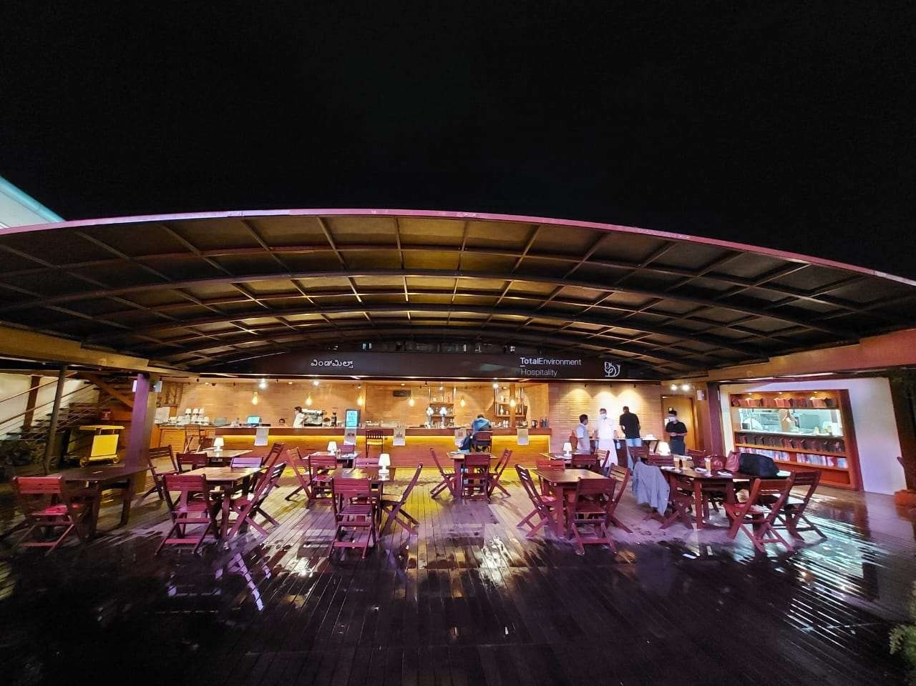
Note: The picture shown here is just for your reference, it is not the final product

(RETRACTABLE ROOF)
- Non Corrosive materials like Aluminium Alloy Profiles, Stainless Steel Fasteners, Rubber sealing
- Polycarbonate Sheet (12 times tougher than toughned glass)
- Lightweight solution for Terraces, Roofing systems, Pools, Veranda Extensions, Balconies, Patios,Smoking Zones and a lot more applications.
- It can be easily Re-Located within a short time by trained technical personal.
- Completely Water proof, can be Air Conditioned

STANDARD FEATURES :-
COLOR OF PROFILES | POWDER COATED – WHITE / BEIZE/ ANTHRACITE / BLACK/ SILVER (COLOUR CAN BE CUSTOMIZED
POLYCARBONATE | 4 mm COMPACT CLEAR / BROWN/ EMBOSSED POLYCARBONATE SHEETS WITH UV PROTECTION.

MEASURE OF CUTOUT :- (Approximate)
Sl. no | DESCRIPTION | WIDTH | LENGTH | HEIGHT | SEGMENT | QTY
1. | SLIDON ROOF ABOVE SWIMMING POOL | 24.1 ft | 82ft | 8 ft | 10 NO | 01No
2 | SLIDON ROOF ABOVE RESTAURANT | 24.4ft | 82ft | 8 ft | 10 NO | 01No

  - 1. ROOF ABOVE SWIMMING POOL

PRICE :-
Sl. NO | PARTICULARS | PRICE
1. | SLIDON ROOF ABOVE SWIMMING POOL
2 | INSTALLATION CHARGES
 | TOTAL
Sl. NO | PARTICULARS | PRICE
1. | DESIGN LASER CUT MILD STEEL SHEET POWDER COATED, SANDWICHED WITH FABRIC TO CUT SUMMER HEAT
 | TOTAL

ADDITIONAL FEATURE OPTIONAL

  - ROOF ABOVE RESTAURANT

PRICE :-
Sl. NO | PARTICULARS | PRICE
1. | SLIDON ROOF ABOVE RESTAURANT
2 | INSTALLATION CHARGES
 | TOTAL

ADDITIONAL FEATURE OPTIONAL
Sl. NO | PARTICULARS | PRICE
1. | DESIGN LASER CUT MILD STEEL SHEET POWDER COATED, SANDWICHED WITH FABRIC TO CUT SUMMER HEAT
 | TOTAL

